**Creating A Table:**

create table student1(

std_id int,

std_name varchar(20)

);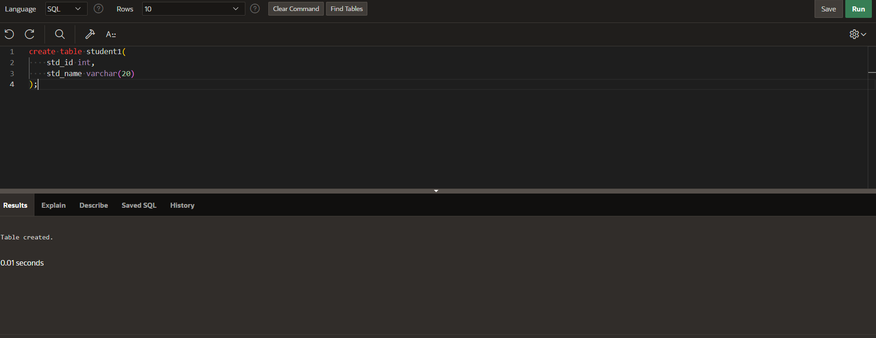

**Modifying Table:**

alter table student1 add marks int;

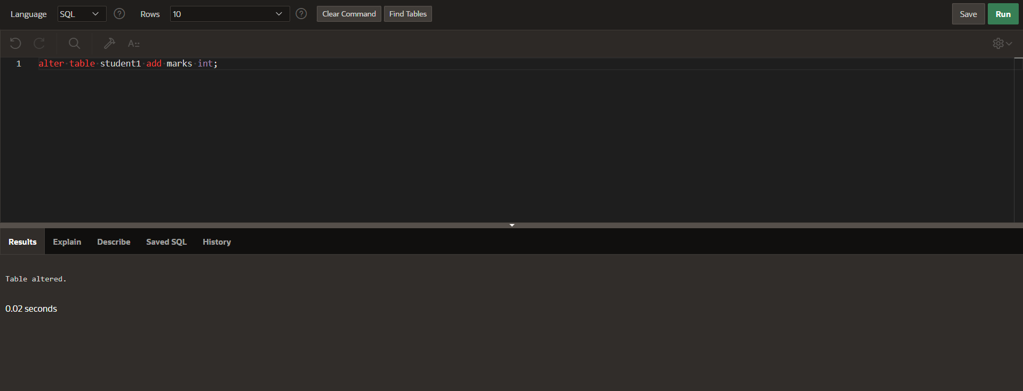

**Describing Table:**

desc student1;

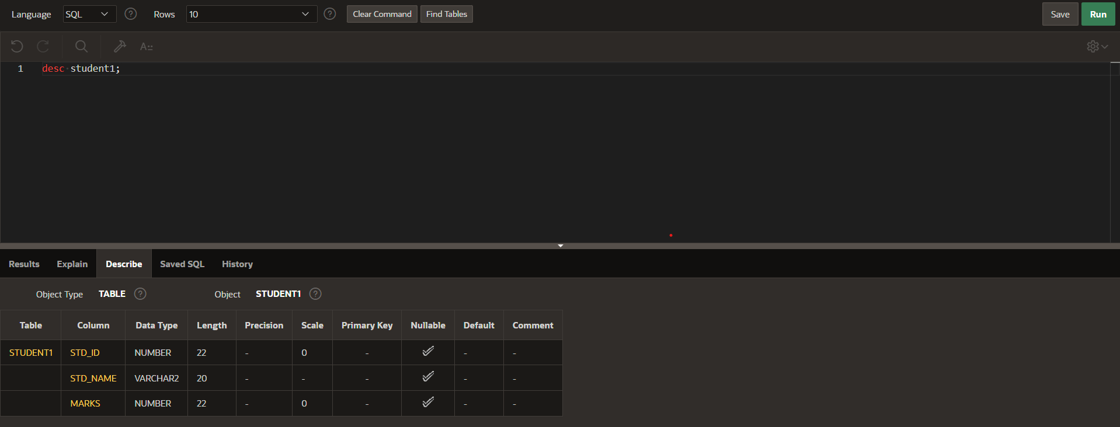

**Inserting Values into Table:**

insert into student1

values(1920,'rupesh',90);

insert into student1

values(1921,’uday',85);

insert into student1

values(1922,’harshit’,87);

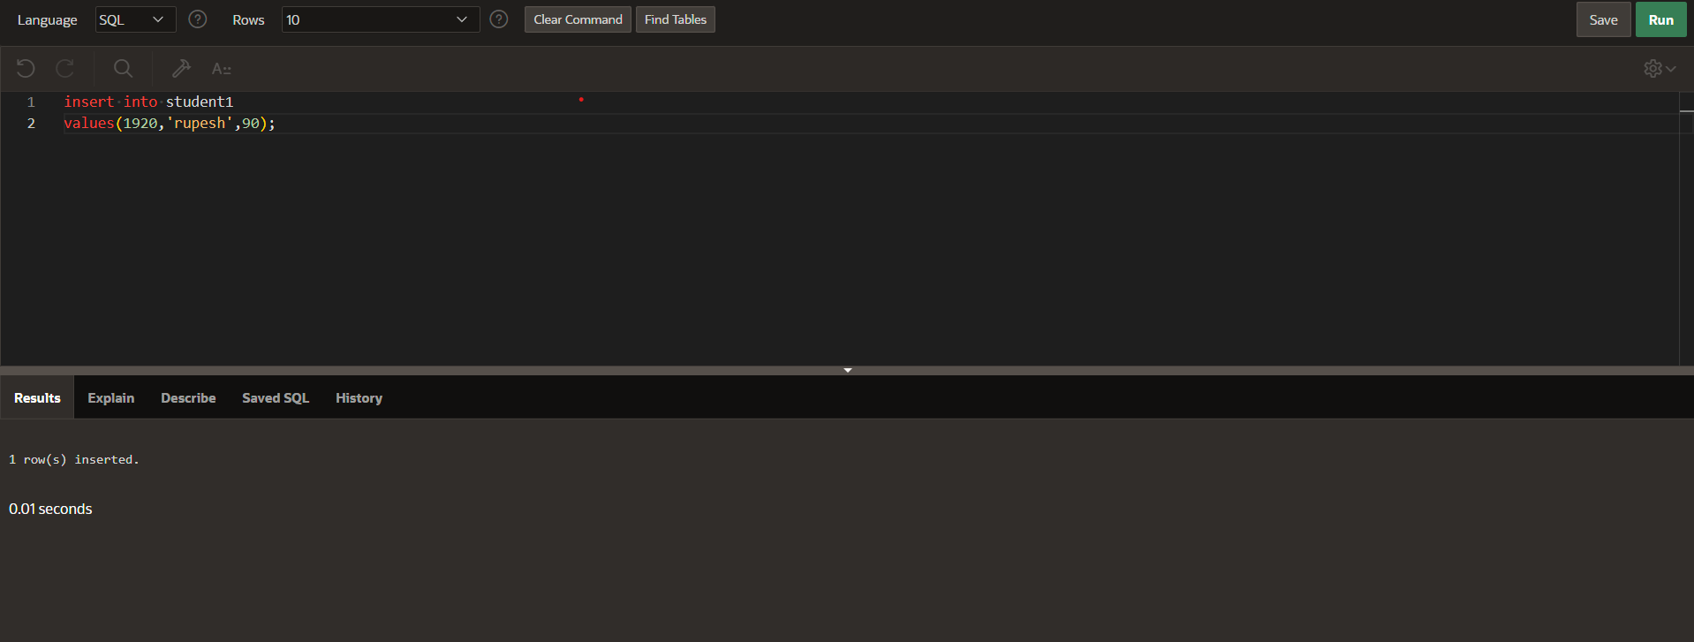

**Updating The Values in Table;**

update student1

set marks=89

where std_id=1922;

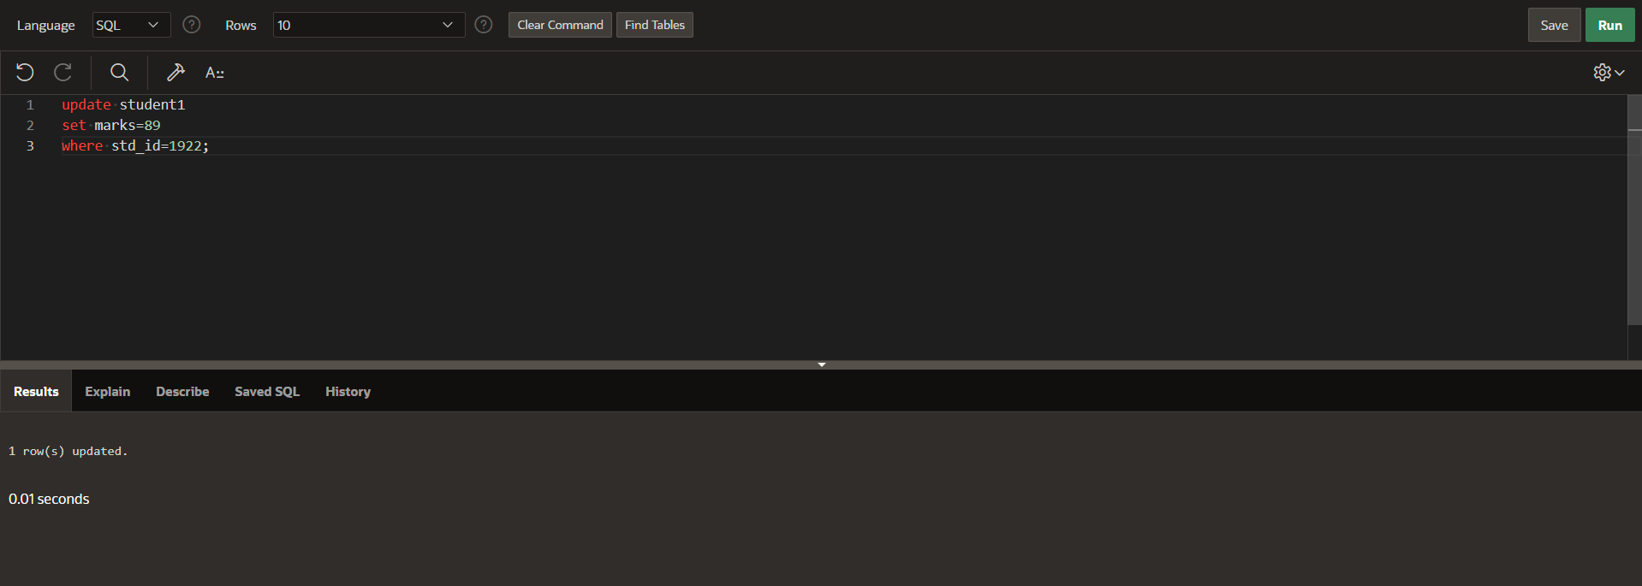

**Displaying The Table with Data:**

select *from student1;

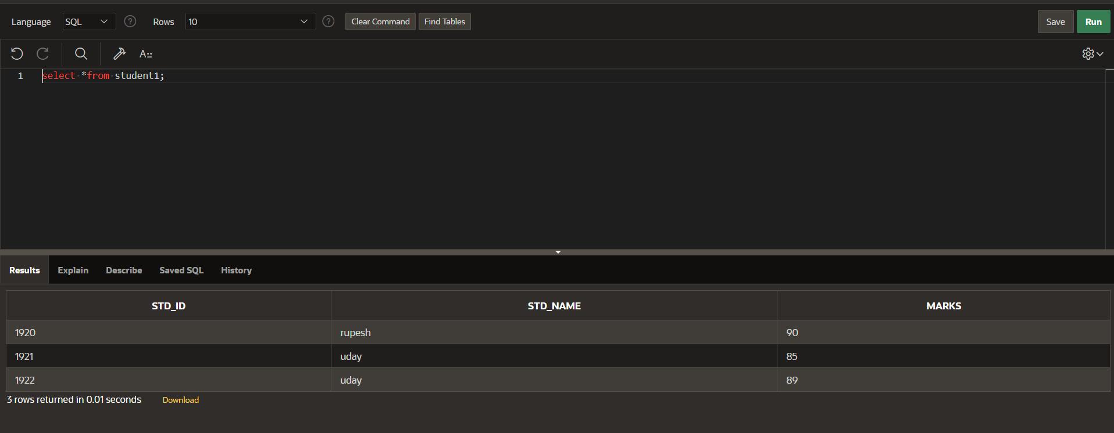

**Displaying The Table In Order of Marks:**

select *from student1

order by marks;

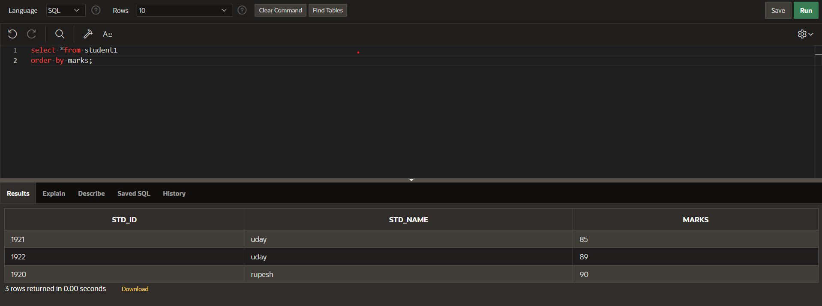

**Displaying Minimum Marks from Table**:

select min(marks)

from student1;



**Displaying Maximum Marks from Table:**

select max(marks)

from student1;

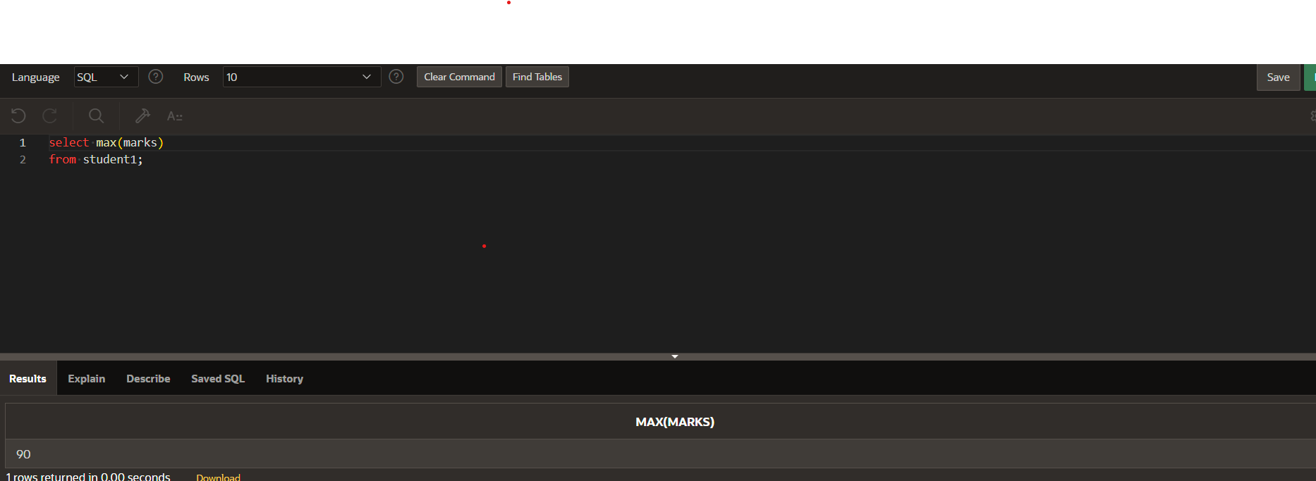

**Displaying The Sum of All Marks:**

select sum(marks)

from student1;

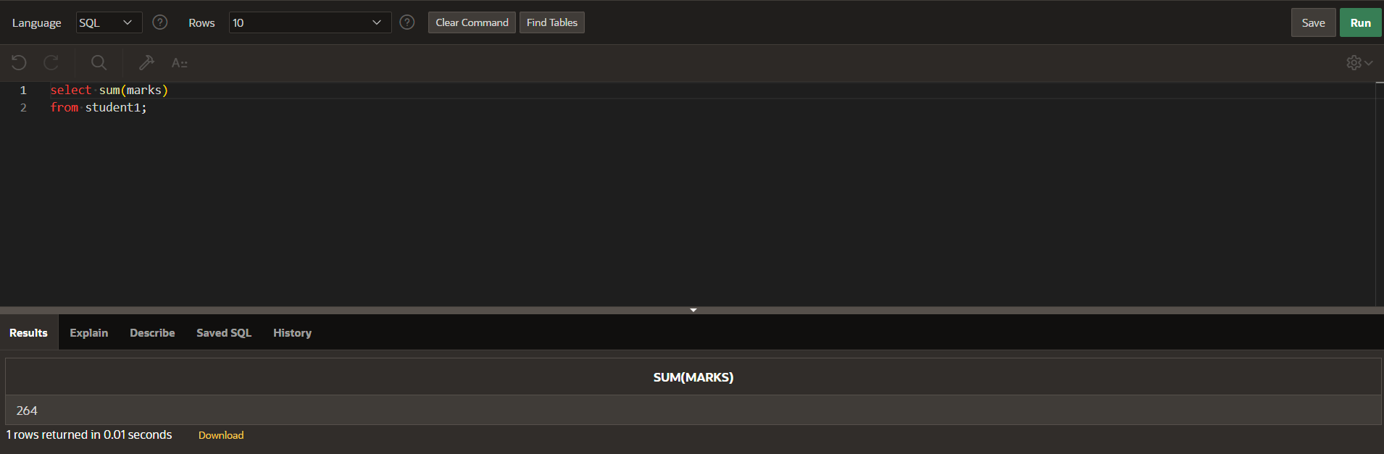

**Displaying Average of Marks:**

select avg(marks)

from student1;

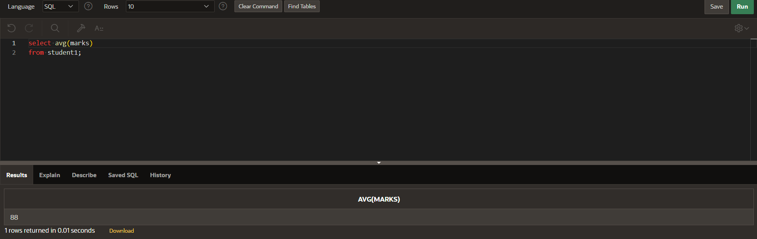

**Counting Number of Students:**

select count(*)

from student1; 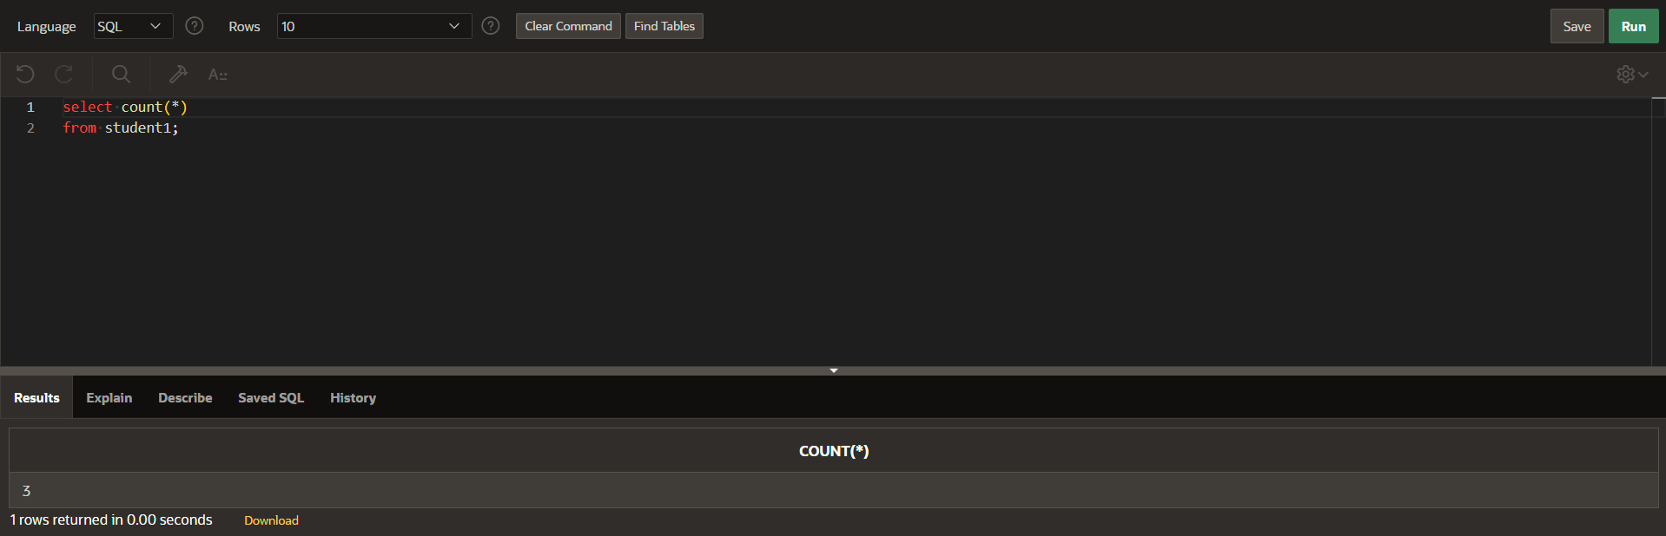

**Deleting a Row:**

delete from student1

where std_id=1922; 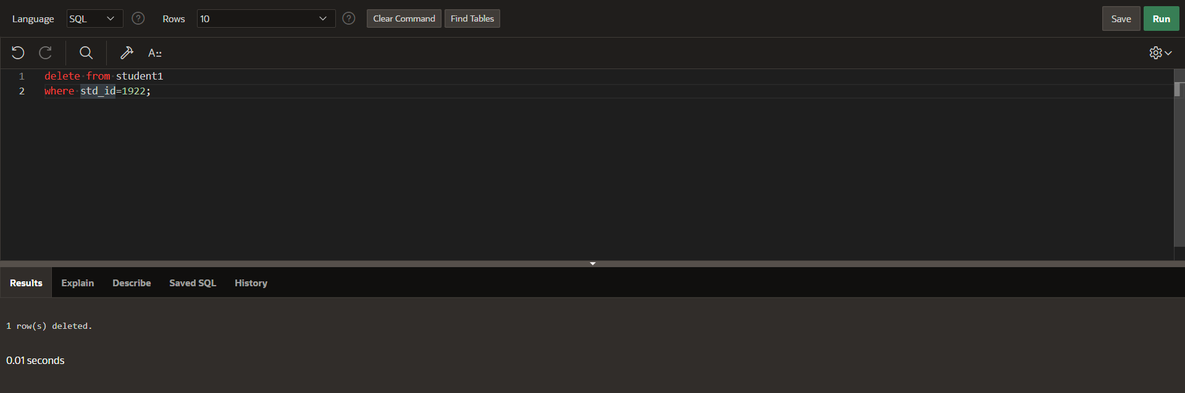

**Truncate The Table:**

truncate table student1;

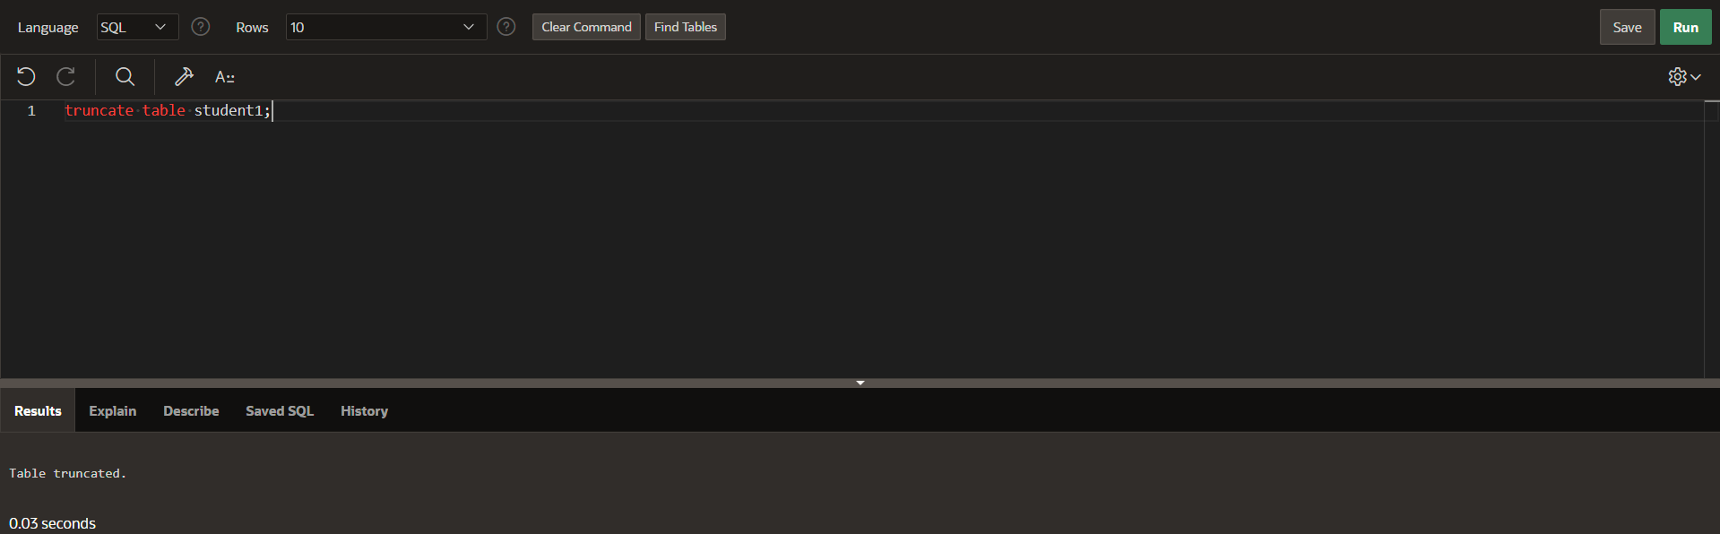

**Drop The Table:**

drop table student1;

